**Chapter-3 Arrays**

**Introduction to Array**

An array is a fundamental data structure that allows you to store a collection of elements of the same type in a contiguous block of memory. An array is used to store a collection of data, but it is often more useful to think of an array as a collection of variables of the same type stored at contiguous memory locations.

Instead of declaring individual variables, such as number0, number1, ..., and number99, you declare one array variable such as numbers and use numbers[0], numbers[1], and ..., numbers[99] to represent individual variables. A specific element in an array is accessed by an index.

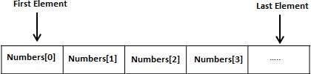

All arrays consist of contiguous memory locations. The lowest address corresponds to the first element and the highest address to the last element.

* Arrays are commonly used to:
* Store and manipulate collections of data efficiently.
* Perform operations on a set of values, such as sorting or searching.
* Represent matrices and grids in mathematical computations.
* Store data retrieved from databases, files, or user input.
* **Declaring Arrays:**

To declare an array in C#, you can use the following syntax –

**datatype[] arrayName;**

where,

* datatype is used to specify the type of elements in the array.
* [ ] specifies the rank of the array. The rank specifies the size of the array.
* arrayName specifies the name of the array.

Eg: double[] balance;

* **Initializing an Array**

Declaring an array does not initialize the array in the memory. When the array variable is initialized, you can assign values to the array.

Array is a reference type, so you need to use the **new** keyword to create an instance of the array.

For example,

double[] balance = new double[10];

* **Assigning Values to an Array**

You can assign values to individual array elements, by using the index number, like :

double[]balance = new double[10];

balance[0] = 4500.0;

You can assign values to the array at the time of declaration, as shown −

double[] balance = { 2340.0, 4523.69,3421.0};

You can also create and initialize an array, as shown −

int [] marks = new int[5] { 99, 98, 92, 97, 95};

You may also omit the size of the array, as shown −

int [] marks = new int[] { 99, 98, 92, 97, 95};

You can copy an array variable into another target array variable. In such case, both the target and source point to the same memory location −

int [] marks = new int[] { 99, 98, 92, 97, 95};

int[] score = marks;

When you create an array, C# compiler implicitly initializes each array element to a default value depending on the array type. For example, for an int array all elements are initialized to 0.

* **Accessing Array Elements**

An element is accessed by indexing the array name. This is done by placing the index of the element within square brackets after the name of the array. For example,

double salary = balance[9];

The following example, demonstrates the above-mentioned concepts declaration, assignment, and accessing arrays −

using System;

namespace ArrayApplication { class MyArray {

static void Main(string[] args) {

int [] n = new int[10]; /* n is an array of 10 integers */ int i,j;

/* initialize elements of array n */ for ( i = 0; i < 10; i++ ) {

n[ i ] = i + 100;

}

/* output each array element's value */ for (j = 0; j < 10; j++ ) {

Console.WriteLine("Element[{0}] = {1}", j,n[j]);

}

Console.ReadKey();

}

}

}

**C# Multidimensional Arrays**

A multidimensional array is a data structure that allows you to store elements in a grid-like format, with multiple dimensions. The most common multidimensional array is a two-dimensional array, which can be thought of as a matrix with rows and columns.

The multidimensional array is also known as rectangular arrays in C#. It can be two dimensional or three dimensional.

To create multidimensional array, we need to use comma inside the square brackets. For example:

int[,] arr=new int[3,3];//declaration of 2D array

int[, ,] arr=new int[3,3,3];//declaration of 3D array

* **Two-Dimensional Arrays**

The simplest form of the multidimensional array is the 2-dimensional array. A 2-dimensional array is a list of one-dimensional arrays.

A 2-dimensional array can be thought of as a table, which has x number of rows and y number of columns.

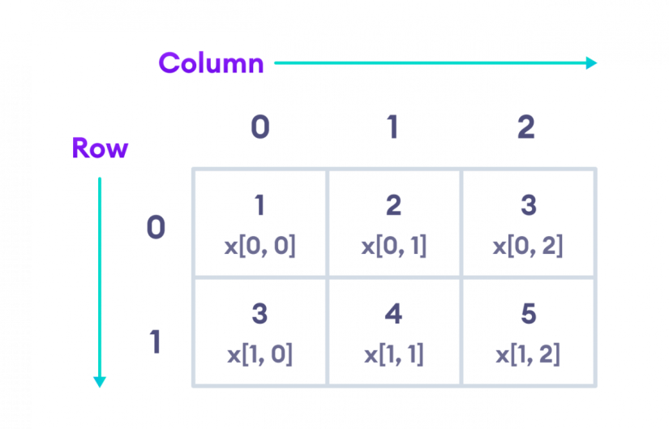

* **Two-Dimensional Array Declaration**

int[ , ] x = new int [2, 3];

* **Two-Dimensional Array initialization**

int[ , ] x = { { 1, 2 ,3}, { 3, 4, 5 } };

* **Declaration and initialization at same time**

int [ , ] x = new int[2, 3]{ {1, 2, 3}, {3, 4, 5} };

* **Access Elements from 2D Array**

// access first element from first row

**x[0, 0];** // returns 1

// access third element from second row

**x[1, 2];** // returns 5

// access third element from first row

**x[0, 2];** // returns 3

Thus, every element in the array x is identified by an element name of the form a[ i , j ], where a is the name of the array, and i and j are the subscripts that uniquely identify each element in array a.

**Example:**

using System;

namespace ArrayApplication

{

class MyArray

{

static void Main(string[] args)

{

int[,] twoDimensionalArray = new int[3, 4];

// Create a 2D array with 3 rows and 4 columns

int value = 1;

// Initialize elements of the 2D array

for (int row = 0; row < 3; row++)

{

for (int col = 0; col < 4; col++)

{

twoDimensionalArray[row, col] = value;

value++;

}

}

// Output each array element's value

for (int row = 0; row < 3; row++)

{

for (int col = 0; col < 4; col++)

{

Console.WriteLine("Element[{0},{1}] = {2}", row, col, twoDimensionalArray[row, col]);

}

}

}

}

}

* **C# Jagged Arrays:** A jagged array is an **array of array** such that member arrays can be of different sizes. Jagged arrays store arrays instead of literal values.

A jagged array is initialized with two square brackets [][]. The first bracket specifies the size of an array, and the second bracket specifies the dimensions of the array which is going to be stored.

Here, the number of rows will be fixed at the declaration time, but you can vary the number of columns.

**Ex.**

int[][] jArray1 = new int[2][]; // can include two single-dimensional arrays

int[][,] jArray2 = new int[3][,]; // can include three two-dimensional arrays

Declaration

In Jagged arrays, user has to provide the number of rows only. If the user is also going to provide the number of columns, then this array will be no more Jagged Array.

int[][] participants = new int[3][];

**Ex:**

using System;

namespace JaggedArrayExample

{

class Program

{

static void Main(string[] args)

{

// Declare and initialize a jagged array

int[][] jaggedArray = new int[3][];

jaggedArray[0] = new int[] { 1, 2, 3 };

jaggedArray[1] = new int[] { 4, 5 };

jaggedArray[2] = new int[] { 6, 7, 8, 9 };

// Access and display elements from the jagged array

Console.WriteLine("Elements of the jagged array:");

for (int row = 0; row < jaggedArray.Length; row++)

{

for (int col = 0; col < jaggedArray[row].Length; col++)

{

Console.Write(jaggedArray[row][col] + " ");

}

Console.WriteLine();

}

}

}

}

* **Params Array(Parameter array):**

Sometimes, you are unaware about a number of parameters or you want to create a method that can accept n number of parameters at runtime. This situation can be handled with params type array in C#. The params keyword creates an array at runtime that receives and holds n number of parameters.You can combine a params argument with other optional parameters, but it must be the last argument in the parameter list, and there can be only one in the function definition.

Syntax:

static int add(params int[] allnumber)

Example:

using System;

namespace params_array

{

class Program

{

static int Add(params int[] allNumbers)

{

int sum = 0;

foreach (int n in allNumbers)

{

sum += n;

}

return sum;

}

static void Main(string[] args)

{

int sum;

// Passing three parameters

sum = Add(1, 2, 3);

Console.WriteLine("Sum of 1, 2, 3 is:\t{0}", sum);

// Passing five parameters

sum = Add(3, 5, 2, 6, 2);

Console.WriteLine("Sum of 3, 5, 2, 6, 2 is:\t{0}", sum);

}

}

}

* **The applications of multi dimensional arrays in C#:**

**1.Representing data in a grid or matrix format:** Multidimensional arrays are a natural choice when you need to represent data in a grid-like structure.

**2.Fixed and known dimensions:** When the dimensions of the data are fixed and known, multidimensional arrays offer a simpler syntax and structure for working with the data.

**3.Performance:** Due to their contiguous memory allocation, multi-dimensional arrays tend to have faster data retrieval .

**4.Simplicity:** Multi-dimensional arrays simplify the syntax for accessing and manipulating elements at different dimensions using a single set of square brackets and indices.

**5.Data Integrity:** Multi-dimensional arrays enforce a fixed size in each dimension, which can be helpful in preventing data inconsistencies and errors.

**6.Compatibility:** Multi-dimensional arrays are supported in most programming languages, making it easy to exchange data and algorithms between different platforms and environments.

* **The applications of jagged arrays in C#:**

1. **Storing data with different lengths or irregular structures:** Jagged arrays are an ideal choice when you need to store data with differing lengths or inconsistent structures
2. **Memory efficiency:** Jagged arrays can help minimize memory usage by only allocating space for the elements you need.
3. **Dynamic Structures:** Useful for implementing dynamic data structures like trees and graphs.
4. **Efficient Allocation:** Facilitates memory allocation in smaller chunks, beneficial for specific scenarios.
5. **Mixed Data Types:** Allows storing different data types across rows.
6. **Faster element access:** It can provide better performance in terms of accessing elements .

* **The applications of params arrays in C#:**

**1. Variable Arguments:** Use `params` arrays to handle different numbers of similar arguments easily.

**2. Simplified Calls:** Make calling methods with multiple inputs straightforward – no need to create arrays first.

**3. Less Overloading:** Instead of many method versions, use one with `params` to cover different argument counts.

**4. User-Friendly:** `params` arrays offer users flexibility to provide any amount of arguments, adapting to their needs.

**5. Readability Boost:** Simplify complex parameter lists for methods with many arguments, making code easier to read.

**6. Compact Array Passing:** Neatly pass arrays as method arguments with `params`, making code cleaner.

**7. Dynamic Flexibility:** Adapt methods on the fly with `params` arrays, handling various input situations without major changes.

* **Array class:**

C# provides an Array class to deal with array related operations. It provides methods for creating, manipulating, searching, and sorting elements of an array. This class works as the base class for all arrays in the .NET programming environment.

**Characteristics of Array Class:**

• In Array, the elements are the value of the array and the length of the array is the total number of item present in the array.

• The lower bound of an Array is the index of its first element and the default value of the lower bound is 0.

**Properties of the Array Class:**

The following table describes some of the most commonly used properties of the Array class –

|  |  |
| --- | --- |
| **S.N** | **Properties & description** |
| **1** | **IsFixedSize**  Gets a value indicating whether the Array has a fixed size. |
| **2** | **IsReadOnly**  Gets a value indicating whether the Array is read-only. |
| **3** | **Length**  Gets a 32-bit integer that represents the total number of elements in all the dimensions of the Array. |
| **4** | **LongLength**  Gets a 64-bit integer that represents the total number of elements in all the dimensions of the Array. |
| **5** | **Rank**  Gets the rank (number of dimensions) of the Array. |

**Ex.**

using System;

namespace ArrayExample

{

class Program

{

static void Main(string[] args)

{

// Creating an array of integers

int[] numbers = { 5, 10, 15, 20, 25 };

// Accessing array elements using indices

Console.WriteLine("First element: " + numbers[0]);

Console.WriteLine("Third element: " + numbers[2]);

// Getting the length of the array

int arrayLength = numbers.Length;

Console.WriteLine("Array length: " + arrayLength);

// Using IsReadOnly property

Console.WriteLine("Is array read-only? " + numbers.IsReadOnly);

// Using Rank property

Console.WriteLine("Array rank (number of dimensions): " + numbers.Rank);

// Sorting the array

Array.Sort(numbers);

// Displaying sorted array

Console.WriteLine("Sorted array elements:");

foreach (int num in numbers)

{

Console.WriteLine(num);

}

}

}

}